**Introduction:** Welcome back to term 3! We hope you and your child were able to enjoy some down time over the last two weeks. We are gearing up for another busy term, which includes our Year 6 camp to Tallebudgera Beach camp and Interschool Sport. This term the students will be starting Chinese again, building on what they learnt last year. Outlined below is our core curriculum content for term 3,along with some key dates and messages. Please also see the homework project for this term. We look forward to an engaging and productive term.

**Teacher contacts**

**6H Mr David Hass –** [**dhass4@eq.edu.au**](mailto:dhass4@eq.edu.au)

**6L Mrs Leanne Reginato –** [**lregi3@eq.edu.au**](mailto:lregi3@eq.edu.au)

**6S Mr John Sainsbury –** [**jsain17@eq.edu.au**](mailto:jsain17@eq.edu.au)

**Key Dates**

Interschool Sports starts – Week 5, 9 August

School Disco – Week 6 , 13 August

Ekka Public Holiday – Week 6, 14 August

First Draft of home project ready to present – Week 7, 19 August

Tallebudgera Camp – Week 8, 26 – 29 August

Pupil Free Day – Week 8, 30 August

Interschool Sport finishes – Week 9, 6 September

Last Day of Term 3 – 13 September

**English**

This term students will be exploring two English Units. The first unit will see the students listen to, read and view extracts from literary texts set in earlier times. They demonstrate their understanding of how the events and characters are created within historical contexts. They create a literary text that establishes time and place for the reader and explores personal experiences.

In the second unit, students will listen to and read literary texts by the same author to identify language choices and author strategies used to influence the reader. They will compare short story and a novel by the same author to identify aspects of author style. Students will prepare a response analysing author style in either the short story or the novel, and participate in a panel discussion.

**Maths**

This term students will locate integers on a number line and locate an ordered pair in any one of the four quadrants on the Cartesian plane. They will recognise the properties of prime, composite, square and triangular numbers. They will solve problems involving division and multiplication. Students will calculate common percentage discounts on sale items and connect fractions, decimals and percentages.

Students will explore and investigate fractions, including locating on a number line, solving problems involving the addition and subtraction of related fractions, and describe rules for sequences involving fractions and decimals. Students will perform calculations on decimals including multiplying and dividing by powers of 10 and make connections between capacity and volume.

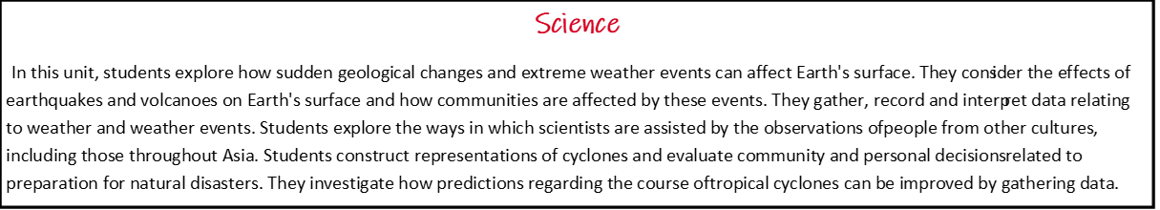

**School Contacts**

**A/Principal Lisa Masek |** lmase3@eq.edu.au

**Deputy Principal (P - 2) Stacey Thomasen |** sthom677@eq.edu.au

**Deputy Principal (3 - 6) Janice Lenarduzzi |** jlena1@eq.edu.au

**A/HOD/C Cara Middleton |** cmidd40@eq.edu.au

admin@sherwoodss.eq.edu.au | (07) 3716 2111 | PO Box 19 Sherwood QLD 4075 | Cnr Sherwood & Oxley Roads | @SherwoodSSOfficial

Do you follow us on Facebook? We post daily at *@SherwoodSSOfficial*

**Homework and Homework Project**

Homework continues to be nightly reading, regular Mathletics tasks and the English Skills textbook.

The focus of the project this term, will be researching a country and investigating it’s economic, demographic and social characteristics. Students will also explore how extreme weather events affect the chosen country. It will also be used to help with one of their English assessments. The project ties in both the HASS and Science unit for this term.

**Technology in the Classroom**

As a school we have revisited the importance of using technology safely and responsibly this week. This has included going over our student checklist for responsible technology use in the classroom.

**Chinese – What is Family?**

This term students will use Chinese language to communicate ideas relating to family and group identity.

**A Bridge Too Far! (Design and Technology)**

In this unit students will investigate the technologies context of engineering principles and systems when exploring the design of bridges. They will generate, develop and communicate design ideas and processes for audiences using appropriate technical terms and graphical representation techniques, and work collaboratively to create a bridge design solution that meets agreed design criteria.

**Media Arts**

Students explore the purpose of music videos and work collaboratively to create a music video.

**H.A.S.S**

This term students will be exploring two HASS units. In the first unit, they will investigate how decision-making benefits the community. Students will investigate a familiar community or regional economics or business issue that may affect the individual or the local community. They examine how the concept of opportunity cost involves choices about the alternative use of resources and the need to consider trade-offs. Students will identify the effect that consumer and financial decisions can have on the individual, the broader community and the environment. They will recognise the reasons businesses exist and the different ways they provide goods and services present findings

In the second unit, students will investigate how places, people and cultures differ across the world. Students will examine the geographical diversity of the Asia region and the location of its major countries in relation to Australia. They will investigate differences in the economic, demographic and social characteristics of countries across the world. Students will consider the world's cultural diversity, including that of its indigenous peoples. They will identify Australia's connections with other countries. They will organise and represent data in large- and small-scale maps using appropriate conventions.